**Week 5 – Hands-on : Microservices with API Gateway**

Exercise : Creating microservices for account and loan

1. First we get the spring project skeleton from Spring Initializr for both account and loan services.

2. Now let’s work on “account” microservice, we create a new package “controller” and then create java class file “AccountController.java”

package com.cognizant.account.controller;  
  
import org.springframework.web.bind.annotation.*;  
  
@RestController  
@RequestMapping("/accounts")  
public class AccountController {  
  
 @GetMapping("/{number}")  
 public Account getAccount(@PathVariable String number) {  
 return new Account(number, "savings", 234343);  
 }  
  
 static class Account {  
 private String number;  
 private String type;  
 private double balance;  
  
 public Account(String number, String type, double balance) {  
 this.number = number;  
 this.type = type;  
 this.balance = balance;  
 }  
  
 public String getNumber() { return number; }  
 public String getType() { return type; }  
 public double getBalance() { return balance; }  
 }  
}

3. Then we run the application “AccountApplication.java”

4. In our browser we navigate to <http://localhost:8080/accounts/001> (any random value works)

**OUTPUT**

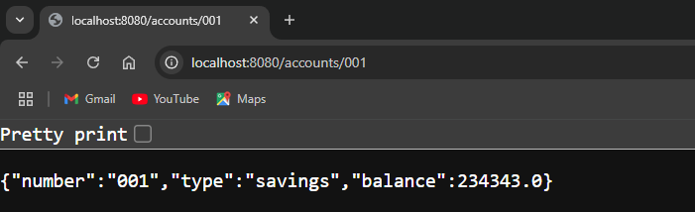

5. Now we open the “loan” project

6. Since we are already running the “account” service on port 8080, we should configure this loan service to run on port: 8081 (for eg.), This is done in “application.properties” as

spring.application.name=loan  
server.port=8081

7. As we did for account service, we create the controller package and create the java class “LoanController.java” in it

package com.cognizant.loan.controller;  
  
import org.springframework.web.bind.annotation.*;  
  
@RestController  
@RequestMapping("/loans")  
public class LoanController {  
  
 @GetMapping("/{number}")  
 public Loan getLoan(@PathVariable String number) {  
 return new Loan(number, "education", 400000, 3258, 18);  
 }  
  
 static class Loan {  
 private String number;  
 private String type;  
 private double loan;  
 private int emi;  
 private int tenure;  
  
 public Loan(String number, String type, double loan, int emi, int tenure) {  
 this.number = number;  
 this.type = type;  
 this.loan = loan;  
 this.emi = emi;  
 this.tenure = tenure;  
 }  
  
 public String getNumber() { return number; }  
 public String getType() { return type; }  
 public double getLoan() { return loan; }  
 public int getEmi() { return emi; }  
 public int getTenure() { return tenure; }  
 }  
}

8. Run the “LoanApplication.java”

9. In the browser navigate to <http://localhost:8080/loans/AC001>

(any random value works)

**OUTPUT**

